#==== Building QGIS documentation in Windows

Many thanks to Rosa ([r.m.aguilardearchila@utwente.nl](mailto:r.m.aguilardearchila@utwente.nl)) for this document 😊

Pre-requisites for this tutorial:

This guidelines uses git command tools, python 3.5 or higher, pip (<https://pip.pypa.io/en/stable/installing/>) and virtualenv (<https://virtualenv.pypa.io/en/latest/>).

Open powershell in admin mode

1. Create a local copy of **your** QGIS doc repository following the steps indicated in: <https://docs.qgis.org/3.4/en/docs/documentation_guidelines/first_contribution.html#using-git-command-line-tools>.
2. Verify that you have origin and upstream repositories as described in <https://docs.qgis.org/3.4/en/docs/documentation_guidelines/first_contribution.html#add-another-remote-repository>
3. Create a virtual environment, e.g., <venv> in the folder created <QGIS-Documentation>.
   1. Virtualenv venv

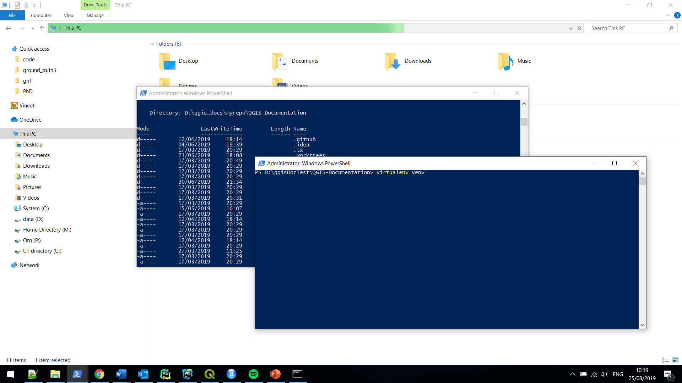

1. Activate the virtual environment
   1. Using the Command Prompt : Run activate.bat

On Windows on Windows, virtualenv creates a batch file

..\QGIS-Documentation \venv\Scripts\activate.bat

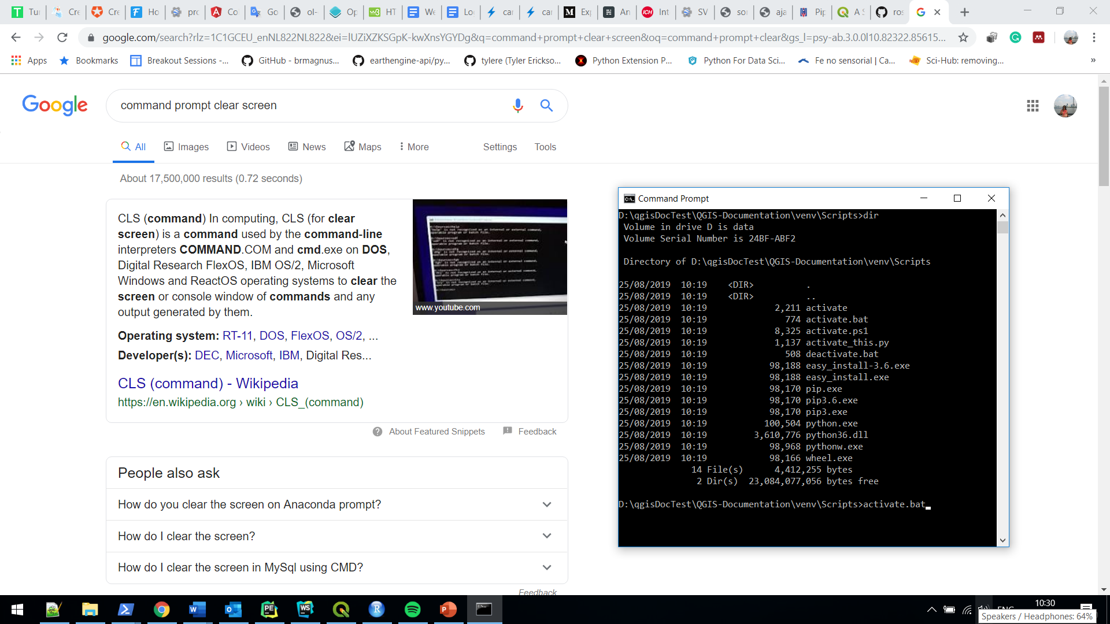

The *activate* script will also modify your shell prompt to indicate which environment is currently active (see the image below).

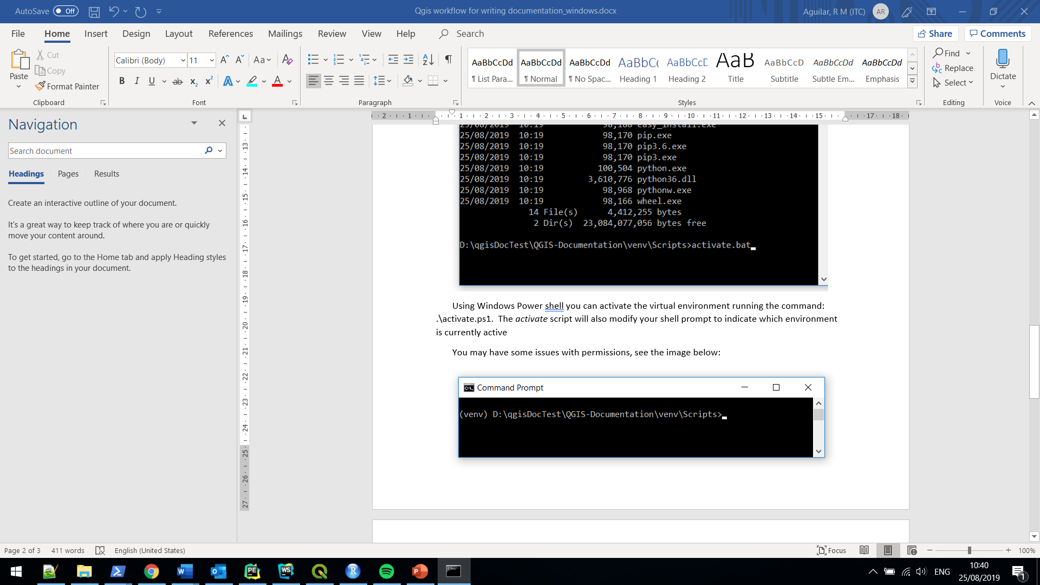

* 1. Using Windows Power shell

You can activate the virtual environment running the command: .\activate.ps1. You may have some issues with the execution policies on your system when it is set to ***Restricted*** meaning that scripts like the *activate.ps1* are not allowed to be executed, see the image below. 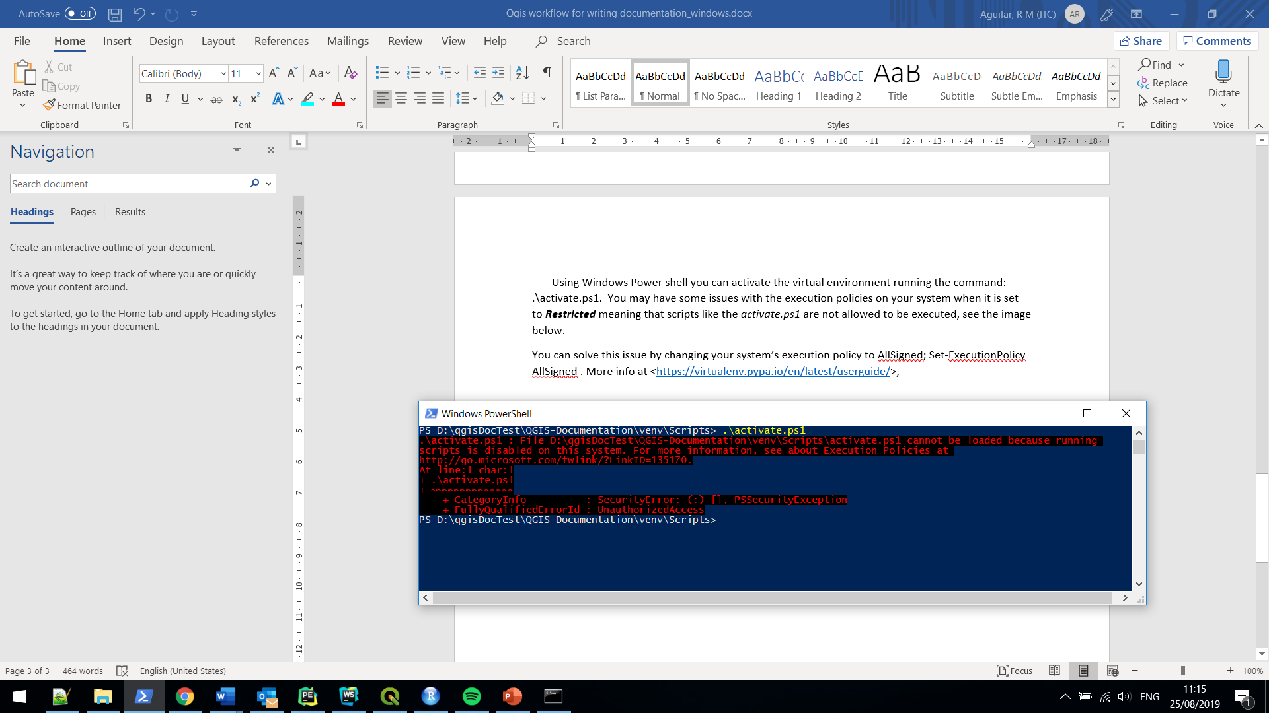

You can solve this issue by temporarily bypassing your system’s execution policy. To do that run, as Administrator, the command <Set-ExecutionPolicy bypass>. Reply yes in the dialog as shown in the following image:

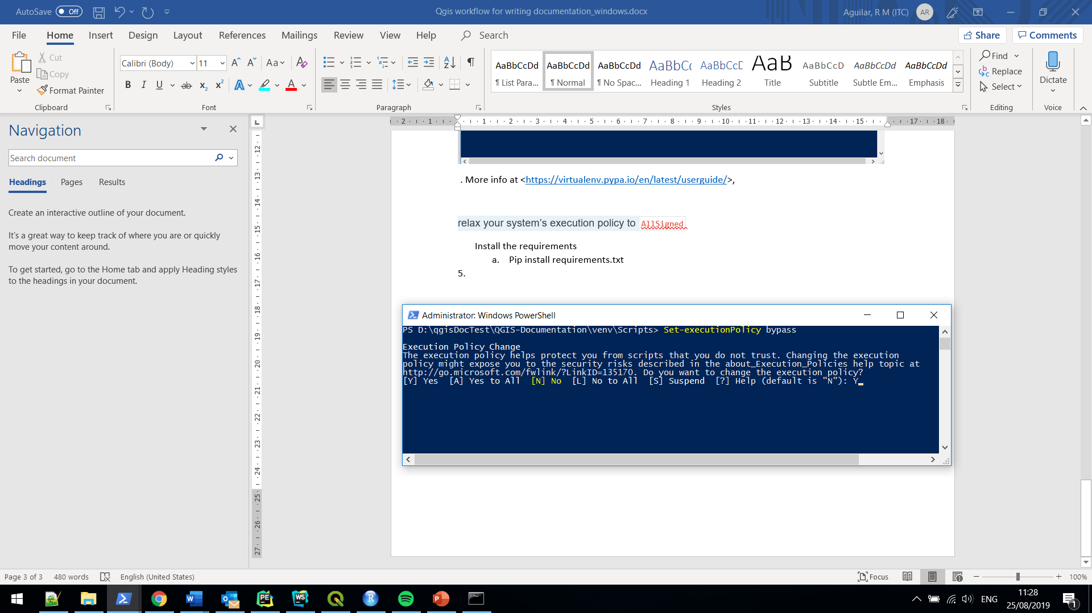

Now, you can run the script to activate the virtual environment <activate.ps1>.

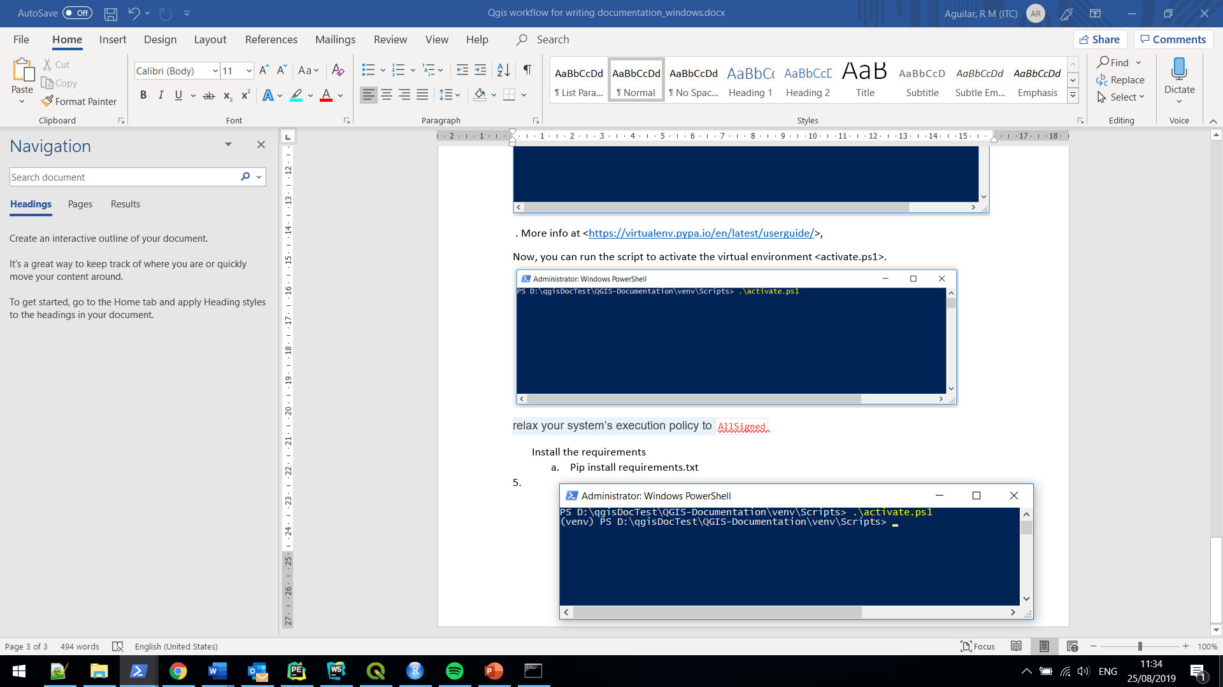

This alternative will allow you to run the activation script in the current Windows session. More info at <<https://virtualenv.pypa.io/en/latest/userguide/>>.

Now, that you have a virtual environment active, you can install the required packages for locally building the QGIS documentation by running <***pip install -r REQUIREMENTS.txt*** >. The requirements.txt file is located in the root folder QGIS-Documentation, see the image below:

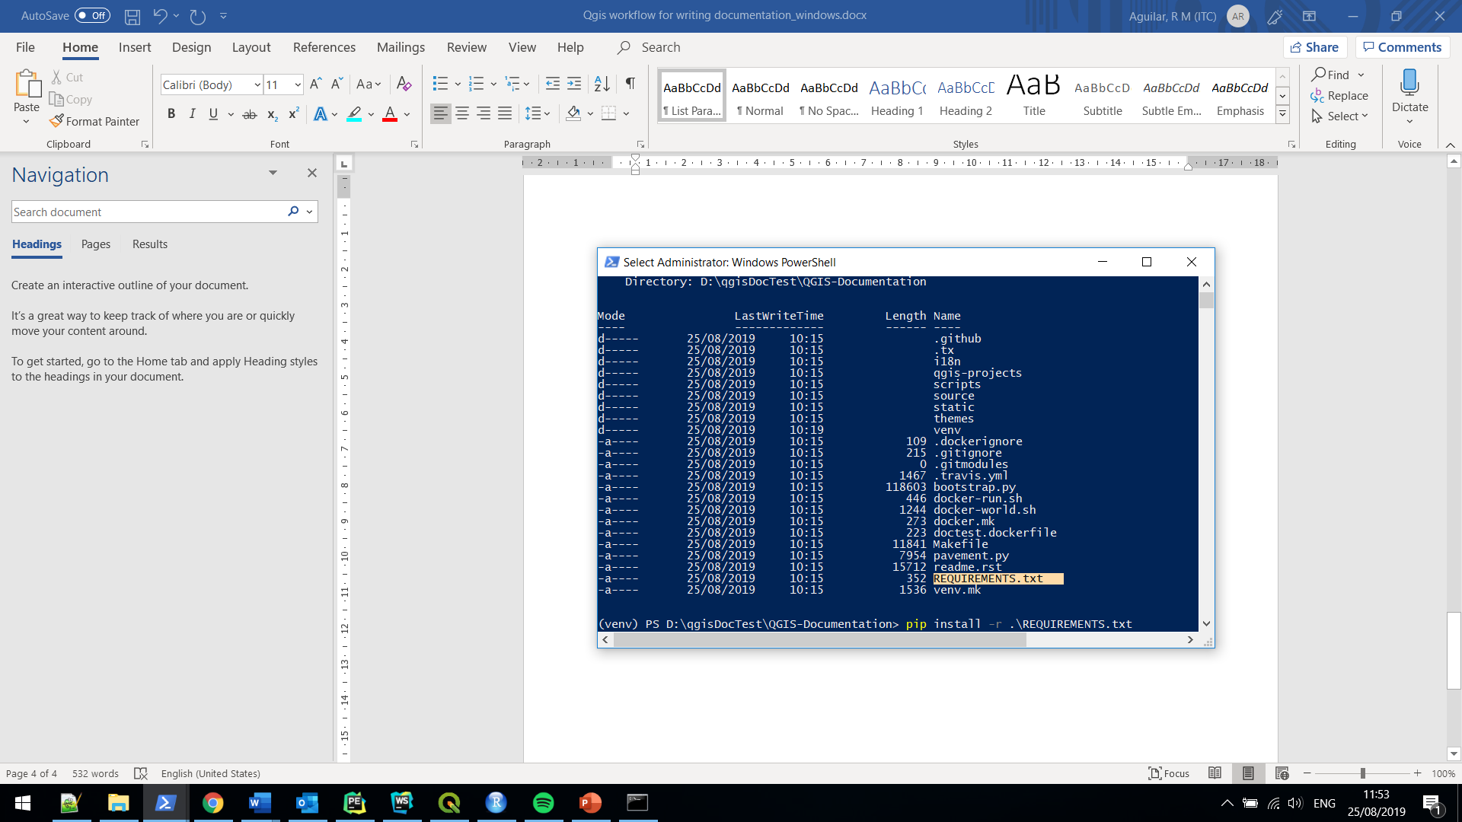

Now you are ready to build the QGIS documentation locally. To do that you run the following sphinx command <sphinx-build -M html ***source*** ***build***>. This will generate the documentation locally in

..\QGIS-Documentation\build\html\docs.